
COMSATS University, Islamabad Pakistan

Codable – Ai Powered Code Learning Platform

By

Abdul Rafay CIIT/FA22-BCS-003/ISB
Khawaja Muhammad Rafay CIIT/FA22-BCS-038/ISB

Supervisor
Prof. Majid Iqbal Khan

Bachelor of Science in Computer Science (2022-2026)

The candidate confirms that the work submitted is their own and appropriate
credit has been given where reference has been made to the work of others.


COMSATS University, Islamabad Pakistan

Codable – Ai Powered Code Learning Platform

A project presented to
COMSATS University, Islamabad

In partial fulfillment
of the requirement for the degree of

Bachelors of Science in Computer Science (2022-2026)

By

Abdul Rafay CIIT/FA22-BCS-003/ISB
Khawaja Muhammad Rafay CIIT/FS22-BCS-038/ISB

DECLARATION
We hereby declare that this software, neither whole nor as a part, has been copied out from any source. It is further declared that we have developed this software and accompanied report entirely on the basis of our personal efforts. If any part of this project is proved to be copied out from any source or found to be a reproduction of some other, we will stand by the consequences. No Portion of the work presented has been submitted of any application for any other degree or qualification of this or any other university or institute of learning.

Khawaja Muhammad Rafay Abdul Rafay

--------------------------- ---------------------------

CERTIFICATE OF APPROVAL
It is to certify that the final year project of BS (CS) Codable was developed by
KHAWAJA MUHAMMAD RAFAY (CIIT/FA22-BCS-038) and ABDUL RAFAY (CIIT/FA22-BCS-003) under the supervision of PROF. MAJID IQBAL KHAN and that in his opinion; it is fully adequate, in scope and quality for the degree of Bachelors of Science in Computer Sciences.

---------------------------------------
Supervisor

---------------------------------------
External Examiner

---------------------------------------
Head of Department
(Department of Computer Science)

EXECUTIVE SUMMARY
In today’s world, learning programming has become a crucial skill, but traditional methods of teaching and practicing coding often fall short in terms of engagement, personalization, and effectiveness. Beginners usually struggle with understanding concepts, building problem-solving skills, handling syntax, and receiving meaningful feedback on their code. At the same time, instructors face challenges in creating structured learning paths, monitoring student progress, and offering timely guidance.
To address these issues, Codable is developed as an intelligent, all-in-one coding learning platform that supports learners throughout their journey—from understanding the basics of programming to mastering structured topics, practicing intelligently, and eventually moving toward real development. The platform integrates AI-driven code evaluation, adaptive question recommendations, and detailed progress tracking to make learning highly personalized and effective.
Codable provides documentation-based lessons, interactive examples, quizzes, and an advanced practice environment where coding questions are customized based on learners’ previous mistakes using an ML-powered recommendation system. It also includes a built-in VS Code–like workspace that allows users to write, run, and debug code while receiving real-time assistance from an AI tutor.
The system further includes a Mentor/Class Management Module, enabling instructors to create classes, assign topics or coding tasks, track student progress, and evaluate submissions efficiently. This ensures the platform works seamlessly for both independent learners and structured, instructor-led training.
Codable is designed with scalability in mind, with the potential to support multiple programming languages in the future—making it a complete and evolving ecosystem for modern coding education.

Abstract
The rationale behind developing Codable is to provide an intelligent, structured, and adaptive platform for learning programming. Traditional tutorials and practice tools focus mainly on syntax, lack personalization, and offer limited support for building strong concepts. They also make it difficult for instructors to track progress or manage coursework effectively.
Codable fills these gaps by combining structured lessons, quizzes, real-time code evaluation, AI-driven feedback, and ML-based question recommendations. Its built-in VS Code–like editor enables hands-on practice with guided assistance, helping learners apply concepts more effectively. For academic use, the Instructor/Class Management Module simplifies class creation, assignments, progress monitoring, and plagiarism checks.
Overall, Codable provides a unified, scalable ecosystem that enhances self-learning, supports instructors, and improves the overall programming education experience.

Acknowledgement
All praise is to Almighty Allah who bestowed upon us a minute portion of His boundless knowledge by virtue of which we were able to accomplish this challenging task.

We are greatly indebted to our project supervisor Prof, Majid Iqbal Khan. Without their personal supervision, advice and valuable guidance, completion of this project would have been doubtful. We are grateful to them for their encouragement and continual help during this work.

And we are also thankful to our parents and family who have been a constant source of encouragement for us and brought us with the values of honesty & hard work.

Khawaja Muhammad Rafay Abdul Rafay

--------------------------- ---------------------------

Abbreviations
SRS | Software Require Specification
PC | Personal Computer
SDS | Software Design Specifications

Table of Contents
Abstract v
1 Chapter 3: Design and Architecture 1
1.1 System Architecture Overview 1
1.1.1 Purpose 2
1.2 Architecture Diagram 2
1.2.1 Technologies and Services 3
1.3 Architecture Style / Pattern 4
1.3.1 Layered Architecture Pattern 4
1.4 Design Models 5
1.4.1 Design Models for Procedural Approach 5
1.5 Data Design 18
3.5.1 Data Storage Approach 18
3.5.2 Major Data Entities 18
3.5.3 Data Storage Technologies 20
3.5.4 Data Processing & Organization 20
3.5.5 Summary 20
2 Chapter 4: Implementation 20
2.1 Project Methodology & Algorithms 20
2.1.1 Project Methodology 21
2.1.2 Algorithm 23
2.1.3 Pseudocode of algorithms 24
2.2 Training Results & Model Evaluation (Mandatory for AI/ML/Data Science Projects) 26
2.3 Security Techniques 26
2.4 External APIs/SDKs 27
2.5 User Interface 29
Login Screen 29
Chapter 5: Testing and Evaluation 33
5.1 Unit Testing 33
5.2 Functional Testing 35
5.3 Integration Testing 37

Chapter 3: Design and Architecture

System Architecture Overview
Codable is designed as a modular and scalable learning platform that combines real-time code execution, AI-driven tutoring, AI-driven evaluation metrices and instructor-led classroom management. The system follows a client-server architecture where users interact through web or mobile interfaces, and all operations are processed by backend services over secure APIs.
The platform consists of the following major components:
- Frontend (Web)
Provides the user interface for students and instructors, delivering course content, coding editors, dashboards, and assessments. Communicates with the backend via REST APIs.
- Backend Services (Node.js/Express)
Acts as the core logic layer responsible for user management, course and chapter handling, code submissions, progress tracking, and instructor tools.
- Authentication & Authorization
Uses JWT-based authentication and role-based access control (RBAC) to secure all user actions and protect restricted features.
- AI & ML Services (Python)
Integrates external LLMs to analyze code, provide feedback, generate personalized questions, and support user skill evaluation.
- Compiler Integration (Websockets)
Executes Java programs using a custom backend compiler powered by javac and JavaParser, with real-time WebSocket communication for instant feedback and safe, interrupt-driven execution.
- Database Layer
Stores users, courses, submissions, progress data, logs, and analytics. A caching layer (Redis) improves performance.
- External Integrations
Includes cloud storage, email services, and third-party AI/ML APIs.
- Security Layer
Ensures secure system operation through HTTPS, JWT validation, firewalls/WAF, input sanitization, and rate limiting.
This architecture provides a clean, scalable, and secure foundation, enabling Codable to support interactive learning, AI-driven insights, and efficient instructor management.

Purpose
The purpose of system architecture overview is to provide a conceptual, big-picture view of the Codable system. It explains the overall structure of the platform by identifying the major modules, where they reside within the system, the technologies involved, and how data and control flow between components. This high-level overview helps stakeholders understand how the system functions before moving into the detailed architecture and implementation in the following sections.

Architecture Diagram
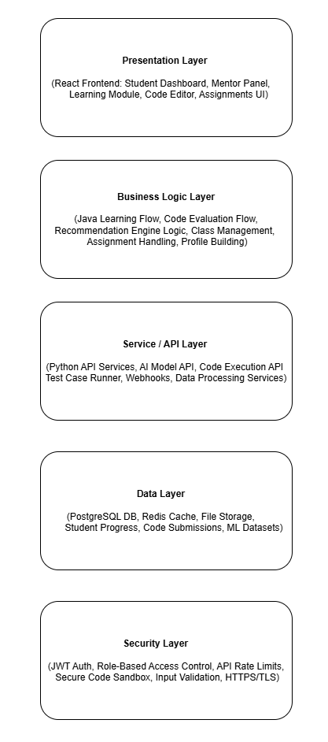

Technologies and Services
Table 3.1 Technologies, Components, and Security Mechanisms Used in the System Architecture
Component | Description | Technology Used | Security Mechanism
Frontend App | User interface for students, mentors, and open Java workspace | React.js with tailwindCSS | SSL/TLS, Input Validation, Role-Based UI Rendering
Backend API (Core Services) | Handles user auth, student/mentor operations, classes, progress tracking, assignments | Node.js (Express.js) | JWT Auth, RBAC, Rate Limiting, Input Sanitization
AI Service (Python API) | Python microservice that calls AI/LLM models, processes user data, and generates personalized learning material | Python (FastAPI / Flask) | Token-Based Access, HTTPS, Data Validation
Code Execution Engine | Real-time code execution using WebSockets; compiles Java with javac and analyzes code using Java Parser | WebSockets, Java Compiler (javac), Java Parser | Sandboxed Execution, Process Isolation, Timeout Limits
Database | Stores users, performance, code submissions, classes, AI evaluations, progress history | MongoDB / PostgreSQL | Encryption at Rest, RBAC, Parameterized Queries
Authentication & Authorization Service | Manages login, signup, JWT tokens, password hashing, user roles | Node.js Auth Middleware, JWT, Bcrypt | Hashed Passwords, Secure Token Storage, Refresh Token Rotation
Mentor Management System | Allows mentors to manage classes, students, assignments, and view progress/plagiarism | Express.js Backend Module | Role-Based Access, Activity Logging
External Integrations | AI API calls, email service, plagiarism detection | Python LLM APIs, SMTP/SendGrid | API Key Protection, HTTPS, Tokenization
Figure: Component-Level Breakdown of Technologies and Security Mechanisms in the System

Architecture Style / Pattern

Layered Architecture Pattern
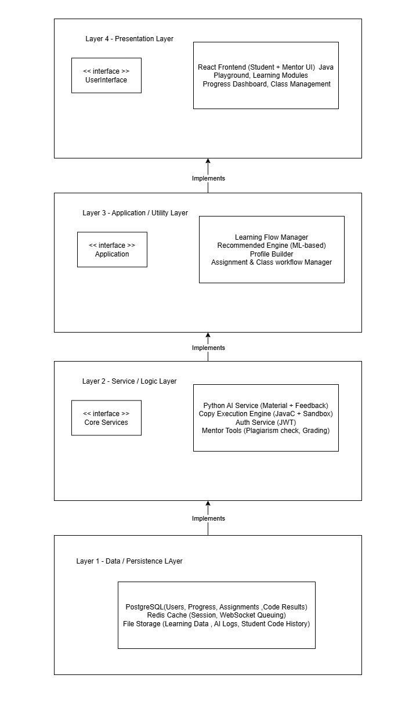

Design Models

Design Models for Procedural Approach
Activity Diagrams

- Student Learning Flow
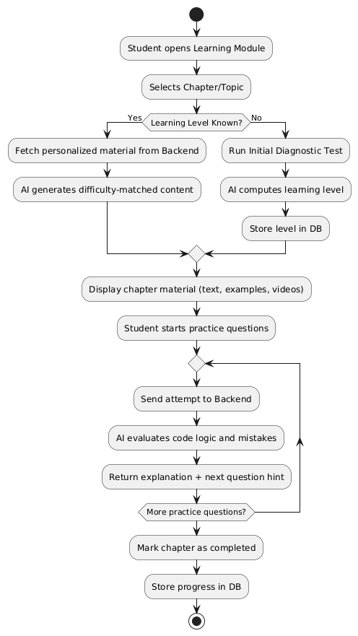

- Code Execution & Ai Evaluation Flow
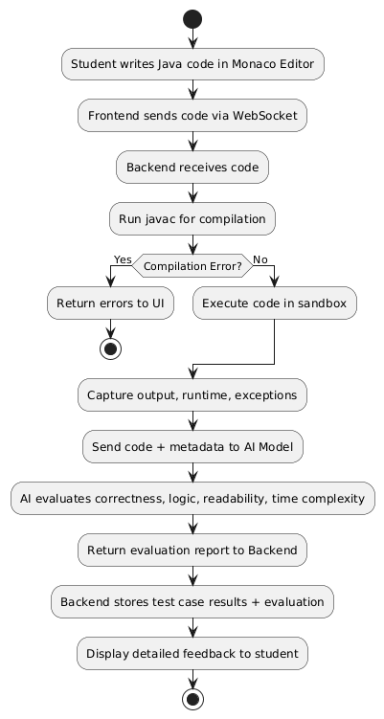

- ML Based Recommendation Engine Flow
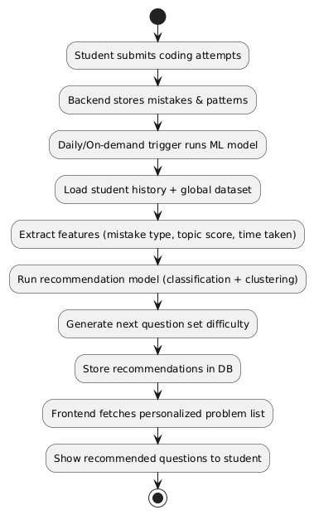

- Student Profile Building

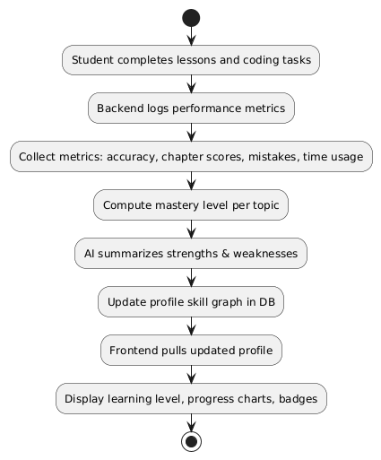

- Mentor – Class Management

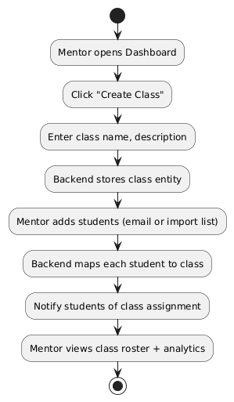

- Mentor – Assignment & Tracking

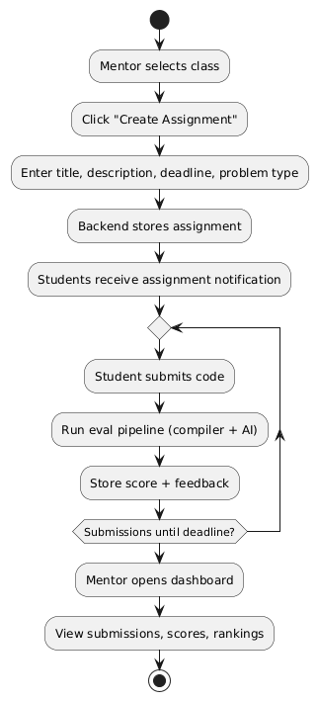

- Plagiarism Detection Flow

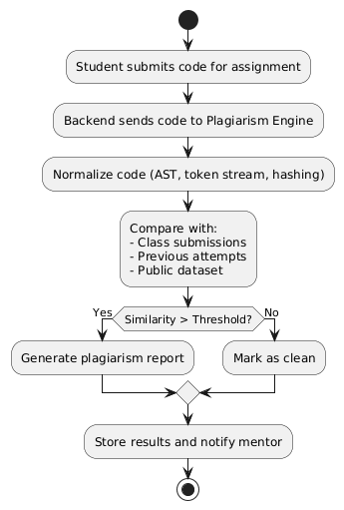

- Student Progress Tracking & Analysis

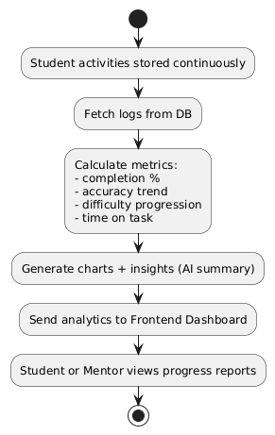

Data Flow Diagrams

- DFD Level 0 — Context Diagram

Shows CODABLE as a single system interacting with external entities (Student, Mentor, AI Model, Compiler) and the high-level data flowing between them
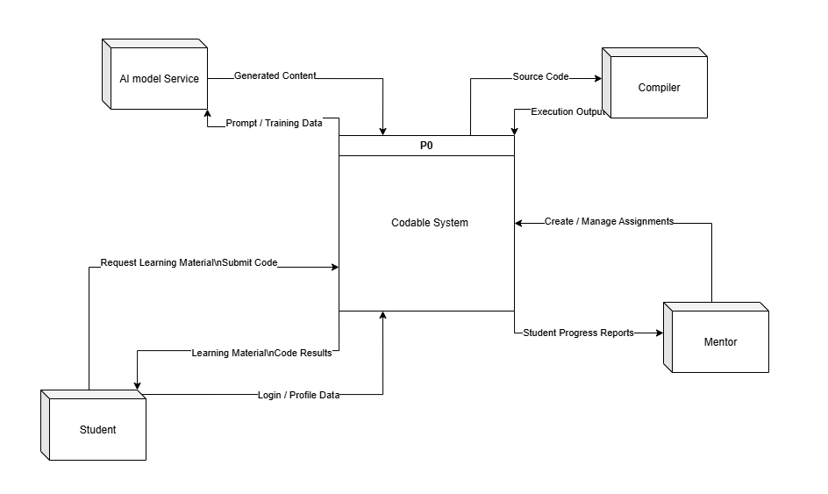

- DFD Level 1 — Diagram 0

Breaks CODABLE into major internal processes (authentication, learning, code execution, performance tracking, mentor tools) and shows how they interact with the main data stores.
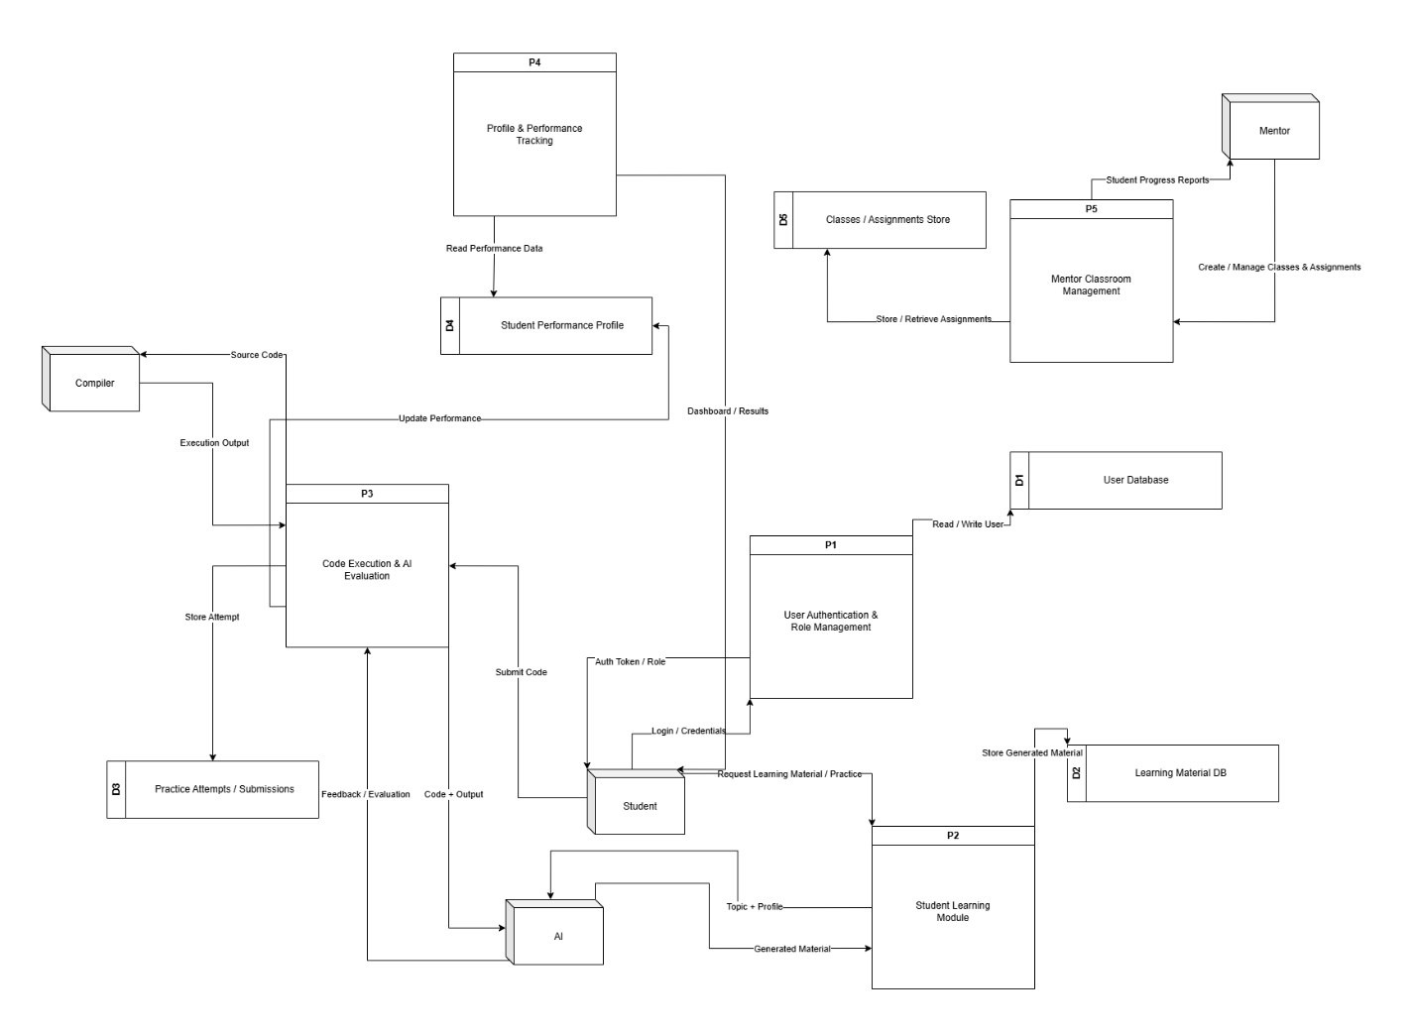

- DFD Level 2 — P2 Student Learning Module

Details how personalized learning material is generated by fetching a student’s profile, determining their level, preparing an AI prompt, and storing the final content.
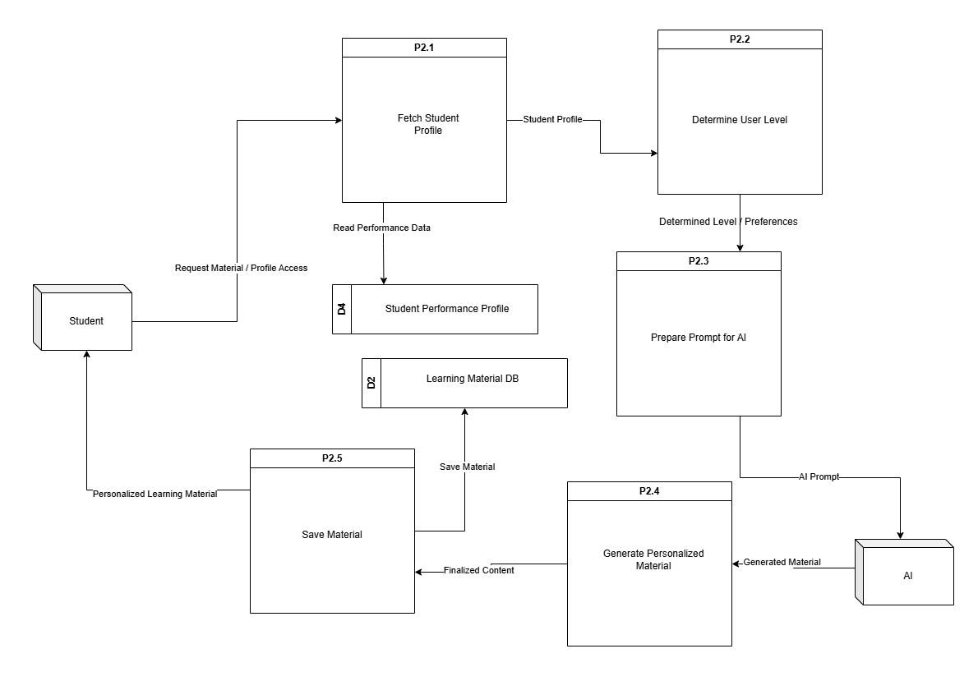

- DFD Level 2 — P3 Code Execution & AI Evaluation

Shows the step-by-step flow of code validation, compiler execution, AI-based evaluation, storing attempts, and updating student performance.
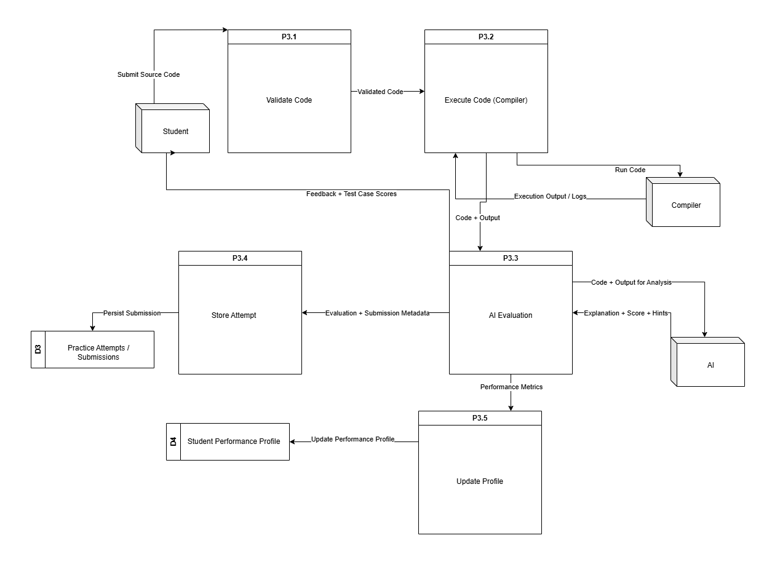

State Transition Diagram
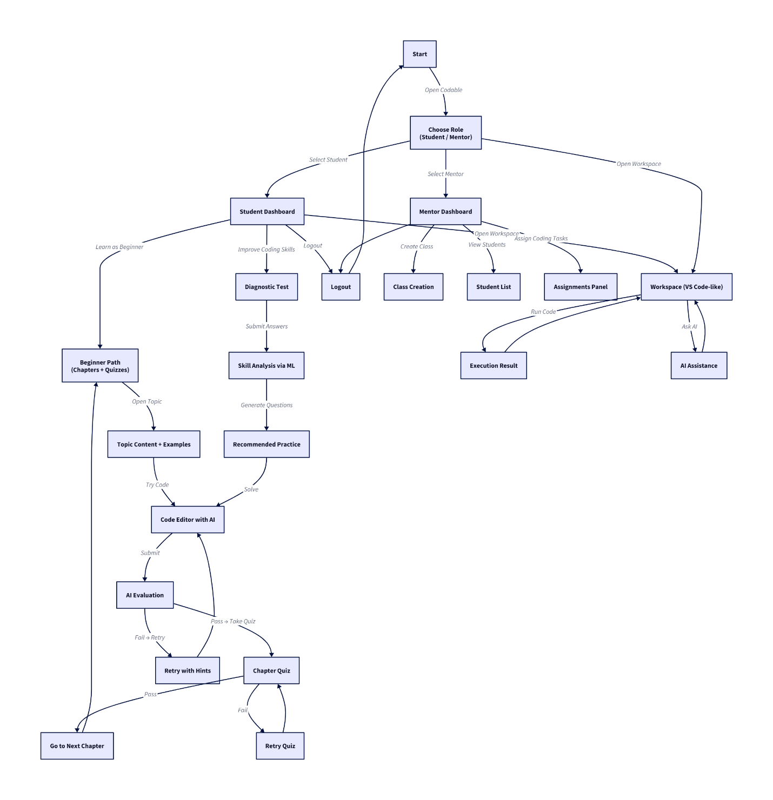

Data Design
This section describes how the information domain of the Codable platform is converted into structured data models and stored across different system components. The system uses a combination of Node.js backend services, a Python AI service, and a Database Layer (MongoDB and PostgreSQL) to manage and organize all user, learning, and performance data.

3.5.1 Data Storage Approach
Codable uses a centralized database where all major entities: users, classes, assignments, code submissions, progress metrics, and AI evaluations, are stored in well-defined data structures. These data models ensure consistent access patterns for both the student-facing and mentor-facing workflows.
The platform follows a modular data structure where each service interacts with specific entities:
- The Node.js backend handles core system entities (users, roles, classes, submissions).
- The Python AI service stores AI-generated content and evaluation metadata back into the database.
- The Code Execution Engine sends execution results that are saved as submission records.

3.5.2 Major Data Entities
The system primarily manages the following major entities:

1. User Entity
Stores information for both students and mentors.
Includes profile details, authentication credentials, role, learning level, and activity logs.

2. Student Learning Profile
Tracks:
- Progress through chapters/topics
- Test results
- AI-generated personalized material
- Weakness areas (concept, logic, syntax)
- Skill metrics

3. Classes (Mentor Module)
Contains:
- Class details
- Students enrolled
- Assignments
- Class-level analytics

4. Assignments / Tasks
Stores mentor-created assignments:
- Problem description
- Test cases
- Deadlines
- Submissions and grading

5. Code Submissions
Each submission includes:
- Submitted code
- Code execution output
- Test cases passed/failed
- AI evaluation feedback
- Time of submission

6. AI-Generated Content
Data created by the Python AI service:
- Personalized learning material
- Topic recommendations
- Difficulty-adjusted exercises
- Code improvement suggestions

7. Progress Tracking Data
Stores continuous metrics such as:
- Number of attempts
- Coding accuracy
- Time spent
- Improvement graphs
- Chapter completion history

8. Authentication & Authorization Data
Includes:
- JWT tokens
- Hashed passwords
- Role-based permissions
- Authentication logs

3.5.3 Data Storage Technologies
Codable can use one of the following database solutions:
Storage Component | Technology | Usage
Primary Database | MongoDB and PostgreSQL | Users, classes, submissions, profiles, assignments
Caching Layer (Optional) | Redis | Session caching, token storage, performance optimization
File Storage (Optional) | Cloud Storage (AWS S3 / Local Storage) | Large files, logs, lesson resources
AI Metadata Storage | Same DB | AI evaluation and recommended content

3.5.4 Data Processing & Organization
- CRUD Operations performed through REST APIs (Node.js).
- AI Evaluation Processing through Python microservice.
- Real-time submission results through WebSockets.
- Relational or Document structure used depending on chosen database:
  - PostgreSQL → structured relational schemas
  - MongoDB → flexible nested documents

3.5.5 Summary
The Data Design ensures that all components of the system: learning engine, mentor tools, AI modules, and code execution engine, maintain consistent, secure, and scalable access to all required information. The data structures support personalized learning, detailed analytics, class management, and continuous skill evaluation.

Chapter 4: Implementation

Project Methodology & Algorithms
This section outlines the core methodology and algorithms used in Codable, focusing on the intelligent and rule-driven components rather than basic CRUD operations. It highlights how the system enforces learning workflows, evaluates code, generates personalized study material, and recommends exercises based on user performance. The described methods include the AI-driven content generation pipeline, code evaluation logic, adaptive learning algorithms, and mentor-side management rules that govern assignments, progress tracking, and skill assessment.

Project Methodology
This section outlines the overall approach used to build Codable, including how each development stage was planned and executed. It briefly explains the workflow followed for designing the curriculum, creating the AI-based evaluation modules, integrating the editor, and developing the ML-driven recommendation system.

- Data Collection
  - What data we are collecting:
    - User activity logs (page views, button clicks, editor run/stop events)
    - Code submissions (source text, language, compile/runtime errors)
    - Performance records (task scores, completion timestamps, attempts)
    - Session / telemetry data (session durations, editor focus, network errors)
    - Authentication metadata (email, join date, membershipTier in User model)
  - How we are collecting data:
    - Frontend event emitters → POST to backend telemetry endpoints
    - WebSocket streams (code-run events and real-time stdout/stderr)
    - Backend persistence: MongoDB collections (User, StudentProfile, CodeRuns, ActivityLogs)
    - Optional external logs: reverse-proxy / server logs and monitoring agent (Prometheus / Grafana)
  - Why this data is important:
    - Populate Profile & Analytics UI (streaks, join date, email, location, bio)
    - Provide persistence for user progress and enable features (leaderboards, weak areas)
    - Feed data pipeline for future analytics or ML features (predictive mastery, personalized suggestions)
    - Debugging and security monitoring (failed compiles, suspicious activity)
- Data Preprocessing
  - Missing Values:
    - Identify missing optional fields (avatar, bio, social links) and substitute defaults (null or empty string)
    - For numeric metrics (timeSpent), substitute 0 or use median imputation if aggregating historical data
  - Duplicates:
    - Use unique keys (userId + timestamp or runId) to deduplicate code run records
    - De-duplicate analytics events by client-generated eventId when available.
  - Normalization:
    - Normalize continuous metrics before modelling: min-max scaling or standardization (z-score) for features like timeSpent, linesOfCode
    - Categorical encoding: one-hot or ordinal encoding for membershipTier, topic tags
  - Aggregation / Anonymization:
    - Aggregate events to daily/weekly buckets for dashboards (dailyActivity)
    - Anonymize or hash user identifiers for datasets used externally or for ML experiments
  - Validation:
    - Validate JSON schema for incoming telemetry (types, bounds) using middleware (Joi / custom validators)
  - Storage format:
    - Persist cleaned records in MongoDB documents and export ML datasets as CSV/Parquet when training offline
- Feature Extraction & Selection
  - Key Features:
    - Code features: linesOfCode, numberOfFunctions, compileErrorsCount, runtimeErrorsCount
    - Interaction features: totalTimeSpent, avgSessionDuration, sessionsPerWeek
    - Performance features: tasksCompleted, successRate (completed/attempts)
    - Behavior features: editorIdleTime, inputRequests (Scanner usage), frequency of runs per session
    - Profile features: membershipTier, joinDate (age), location (region)
  - Extraction and Selection:
    - Parse code submissions to extract simple AST metrics (token count, bracket depth, imports)
    - Derive time aggregates from raw events (sessionization by sessionId)
    - Feature filtering: remove low-variance features and highly correlated features (correlation threshold)
    - Use domain knowledge: prefer features that align with pedagogy (timeSpent + attempts → mastery)
    - Optionally apply dimensionality reduction (PCA) before clustering or visualization
- Model Training
  - Algorithm(s): State the machine learning or AI models used (e.g., Random Forest, CNN, LSTM).
  - Training: Mention dataset split (train/test) and evaluation method.
  - Why: Explain why this model was chosen for the problem.
- Deployment
  - What tech is used:
    - Frontend: React (Vite) SPA with routes for roles, workspace, and profile pages
    - Backend: Express server with REST endpoints and WebSocket code-run service
    - Database: MongoDB for Users and StudentProfiles
    - Real-time: WebSocket server for compile/run streams
    - Monitoring: logging + optional metrics dashboards
  - How it can be deployed:
    - Host backend on a Node-capable host (e.g., VPS, cloud VM, or managed services); use NGINX reverse proxy + TLS
    - Use MongoDB Atlas or managed MongoDB for persistence
    - Serve the built frontend via CDN or static host (Netlify, Vercel) with CORS configured
    - For WebSocket TLS (wss://) use same host or dedicated domain behind NGINX
    - CI/CD: GitHub Actions to run tests and deploy builds
  - Why:
    - Real-time feedback (WebSocket) improves learning flow
    - Persistent profiles and analytics enable personalized learning and progress tracking
    - Production safety via sandboxing and secure auth protects users and infrastructure

Algorithm
This section presents the key algorithms powering Codable, focusing on intelligent features. Each algorithm includes its name, input, output, and pseudocode, avoiding trivial operations and highlighting logic-driven and ML-based processes used in the system.

Table 4.1: Algorithms
Algorithm Name | Details
JavaCodeCompileAndRun (WebSocket Code Runner) | Input: sessionId (string), sourceCode (string), runOptions { timeoutMs, stdinAllowed, outputLimitBytes }  Output: streamed messages to client ({type:'compile-error'|'stdout'|'stderr'|'done'}) and finalResult { exitCode, runtimeMs, status }  Description / High-level steps:  - Create isolated temporary working directory for sessionId.  - Persist sourceCode as Main.java.  - Spawn javac to compile; capture compile stderr.  - If compile fails → send compile-error and cleanup.  - If compile succeeds → spawn java process, stream stdout/stderr to client over WS, accept stdin messages from client.  - Enforce ExecutionGuard constraints (timeout, output limits).  - On process exit or enforced kill → send done message and cleanup temp directory.
ExecutionGuard (Timeout & Output Enforcement) | Input: processHandle, guards { maxRuntimeMs, maxOutputBytes }  Output: guardResult { status: 'ok'|'killed-timeout'|'killed-output', reason }  Description / High-level steps:  - Monitor elapsed runtime; if exceeds maxRuntimeMs, terminate process.  - Accumulate emitted output size; if exceeds maxOutputBytes, terminate process.  - On process exit clear monitors and return status.
StudentProfileUpsert (Single-Profile Rule) | Input: userId, payload { fullName?, avatar?, bio?, location?, socialLinks? }  Output: profileDocument, status {'created'|'updated'}  Description / High-level steps:  - Query StudentProfile by userId.  - If not found → create profile (use User.name or email local-part as default fullName), save and return created.  - If found → merge provided fields (partial update), save and return updated.  - Ensure uniqueness constraint on userId to prevent duplicates.
Ai/Ml Alogirthm here

Pseudocode of algorithms
- Algorithm: JavaCodeCompileAndRun
procedure JavaCodeCompileAndRun(sessionId, sourceCode, runOptions)
tempDir ← CreateTempDir(sessionId)
WriteFile(tempDir + "/Main.java", sourceCode)

compileProc ← SpawnProcess("javac", ["Main.java"], cwd=tempDir)
compileErrors ← CaptureStderr(compileProc)
wait compileProc to finish

if compileProc.exitCode ≠ 0 then
SendToClient(sessionId, { type: "compile-error", data: compileErrors })
Cleanup(tempDir)
return
end if

SendToClient(sessionId, { type: "compile-success" })
runProc ← SpawnProcess("java", ["Main"], cwd=tempDir, stdio=pipes)
startTime ← Now()

start ExecutionGuard(runProc, runOptions)

concurrently:
stream runProc.stdout → SendToClient(sessionId, { type: "stdout", data })
stream runProc.stderr → SendToClient(sessionId, { type: "stderr", data })
on ws message of type 'stdin' write to runProc.stdin

wait for runProc to exit or be killed
runtimeMs ← Now() - startTime
SendToClient(sessionId, { type: "done", exitCode: runProc.exitCode, runtimeMs })
Cleanup(tempDir)
end procedure

- Algorithm: ExecutionGuard
procedure ExecutionGuard(processHandle, guards)
startTime ← Now()
totalOutput ← 0

on process stdout or stderr chunk:
totalOutput += chunk.length
if totalOutput > guards.maxOutputBytes then
Kill(processHandle)
return { status: "killed-output", reason: "output limit exceeded" }
end if
end on

every 100ms:
if Now() - startTime > guards.maxRuntimeMs then
Kill(processHandle)
return { status: "killed-timeout", reason: "timeout" }
end if
end every

on process exit:
clear interval
return { status: "ok" }
end procedure

- Algorithm: StudentProfileUpsert
procedure StudentProfileUpsert(userId, payload)
existing ← StudentProfile.findOne({ userId })
if existing == null then
user ← User.findById(userId)
profile ← new StudentProfile({
userId,
fullName: payload.fullName OR user.name OR localPart(user.email),
avatar: payload.avatar OR null,
bio: payload.bio OR "",
location: payload.location OR { city:"", country:"" },
socialLinks: payload.socialLinks OR { github:"", linkedin:"", twitter:"" }
})
profile.save()
return { profile, status: "created" }
else
if payload.fullName provided then existing.fullName ← payload.fullName end if
if payload.avatar provided then existing.avatar ← payload.avatar end if
if payload.bio provided then existing.bio ← payload.bio end if
if payload.location provided then merge location fields end if
if payload.socialLinks provided then merge social links end if
existing.save()
return { profile: existing, status: "updated" }
end if
end procedure

Training Results & Model Evaluation (Mandatory for AI/ML/Data Science Projects)
- Describe:
  - Dataset used (name, source, pre-processing)
  - Training setup (platform, GPU/CPU, batch size, epochs)
  - Performance metrics
  - Screenshots of graphs (loss, accuracy, confusion matrix, ROC if applicable)

Security Techniques
Authentication:

- JWT-based auth: tokens signed with process.env.JWT_SECRET and issued at login (token expiry configured).
- Password hashing: bcrypt used in User model pre('save') hook (salt rounds ≈ 10).
- Auth middleware: authMiddleware.userAuth verifies token (reads token from request header token) and sets req.userId for protected routes.
- Request validation middleware: authMiddleware.validate(schema) present and used on auth routes.

Transport & secrets:

- Environment secrets loaded via dotenv (JWT secret, DB URI, etc.).
- CORS configured in server (FRONTEND_ORIGIN) to limit origins.

Input validation & persistence

- Route-level request validation middleware applied to critical endpoints (auth/profile).
- Mongoose schemas enforce required/unique fields (e.g., unique email, unique userId on StudentProfile) and use timestamps (createdAt/updatedAt).

Runtime safety for code execution

- WebSocket code-runner implemented:
- Uses per-session temporary working directory for compilation/execution.
- ExecutionGuard enforces max runtime and output limits; kills runaway processes.
- Streams compile/runtime stdout & stderr back to client; supports stdin messages.
- Cleans up temp dirs and terminates processes on disconnect or guard triggers.

- Logging & error handling

- Basic structured error logging (console.error) in controllers/middlewares and centralized error responses.
- Auditable events for profile CRUD and code-run errors are produced (logged).

External APIs/SDKs
This section covers all third-party SDKs, libraries and external APIs used in the project. It distinguishes between (a) external networked services/APIs you call at runtime (e.g., Stripe, Cloudinary, external LLMs) and (b) third-party libraries/SDKs installed via npm that provide functionality within the app (e.g., Express, Mongoose, Monaco Editor). For each item we list a short description, the purpose it serves in the system, and the specific files, functions or endpoints where it is integrated. Use the table below to document exact version numbers and invocation points.

Table 4.2 Details of APIs used in the project
Name of API /SDKS and version | Description | Purpose of usage | List down the API endpoint/function/class in which it is used
bcryptjs | Password hashing library | Hashing passwords and compare on login | src/models/User.js (pre('save') hash, comparePassword method)
jsonwebtoken | JWT creation/verification | Issue tokens at login and verify in auth middleware | src/models/User.js (generateToken), src/middlewares/authMiddleware.js (userAuth verification)
ws (WebSocket) | WebSocket server library | Real‑time compile/run streaming between client and server | src/websocket/codeRunner.js (startWebSocketServer, connection/message handlers)
axios | Promise HTTP client (frontend) | API requests from frontend to backend (auth, profile) | src/services/userApi.js (getUserProfile, updateUserProfile, etc.), used across pages/components
@monaco-editor/react (monaco-editor) | Browser code editor | IDE editor in Workspace page | src/pages/Workspace/Workspace.jsx (MonacoEditor component integration)
lucide-react | Icon components | UI icons used in header, splash, etc. | src/pages/Student/ProfileAndAnalytics/components/ProfileHeader.jsx etc
recharts | Charting library | Render analytics charts on Profile & Analytics pages | src/pages/Student/ProfileAndAnalytics/* (charts components)
dotenv | Environment variable loader | Load process.env values (JWT_SECRET, DB URI) | src/server.js (dotenv.config()
cors | CORS middleware | Restrict allowed frontend origin for API access | src/server.js (app.use(cors({...})))

User Interface

Login Screen
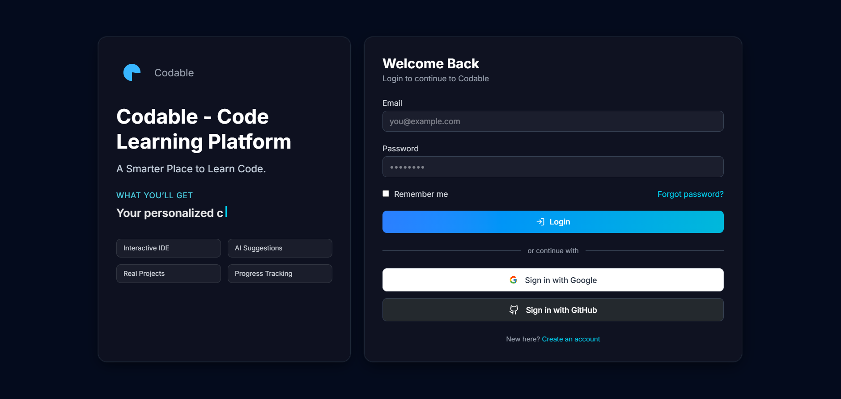

  - Purpose: Authenticate users.
  - Key components: email/password fields, "Login" button, "Forgot password" link.
  - Primary actions: submit credentials, show errors.

Role Selection Dashboard
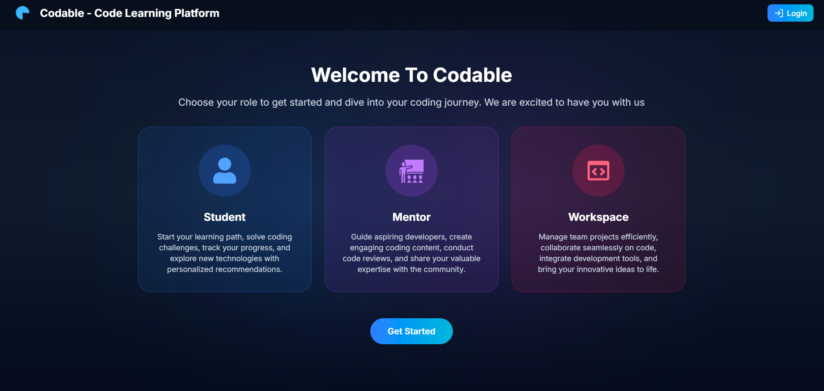
  - Purpose: First-time landing and choose role (student/mentor).
  - Key components: branding/logo, brief pitch, role buttons, continue CTA.
  - Primary actions: select role → navigate to onboarding or dashboard.
  - Client: sessionStorage flag to show once per session

Student Dashboard
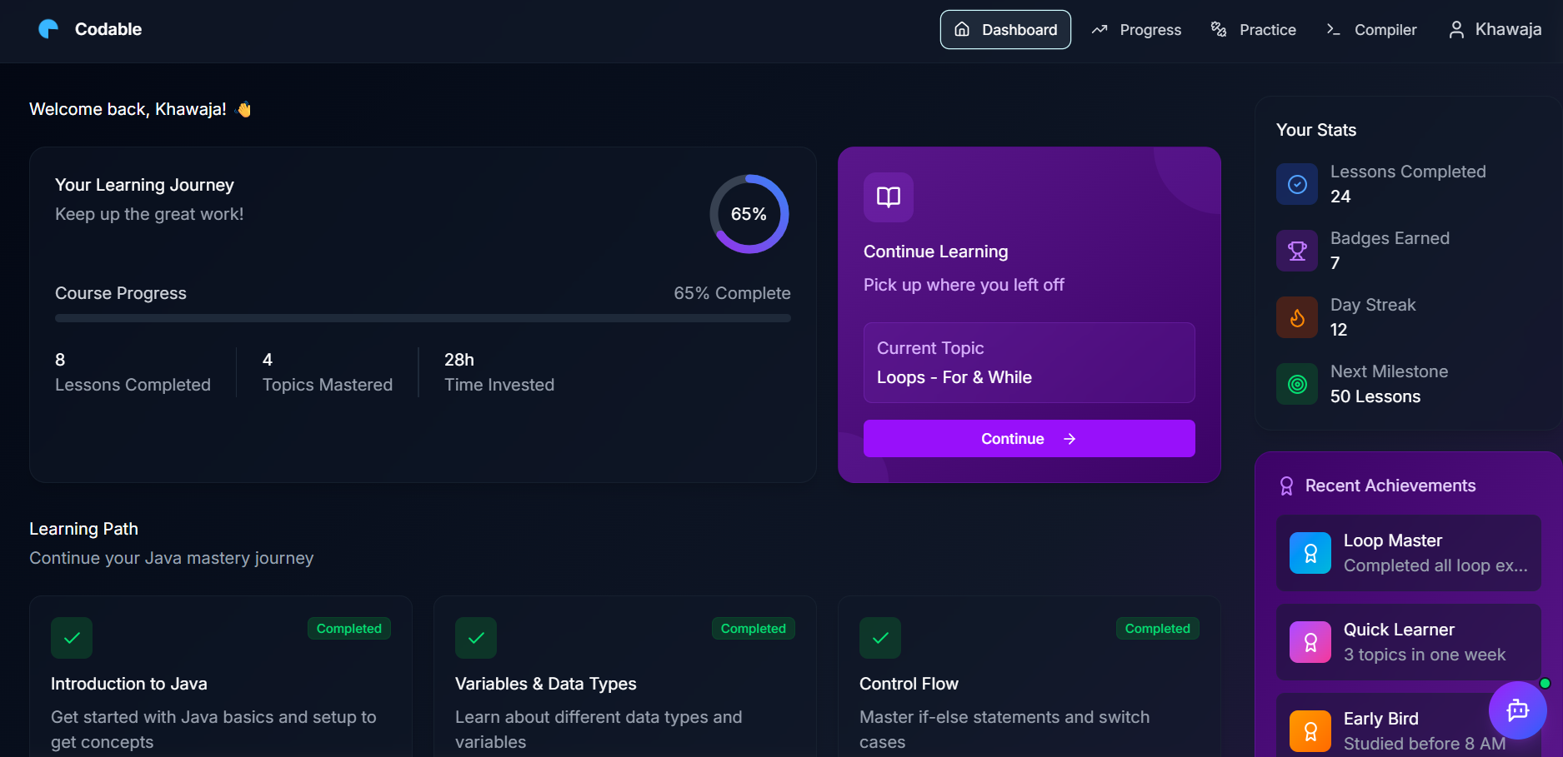
- Purpose: Entry hub showing progress, quick actions and recommended tasks.
- Key components: stats cards, recent activity, quick links (Workspace, Courses), notifications.
- Primary actions: open workspace, continue course, view profile.

Workspace
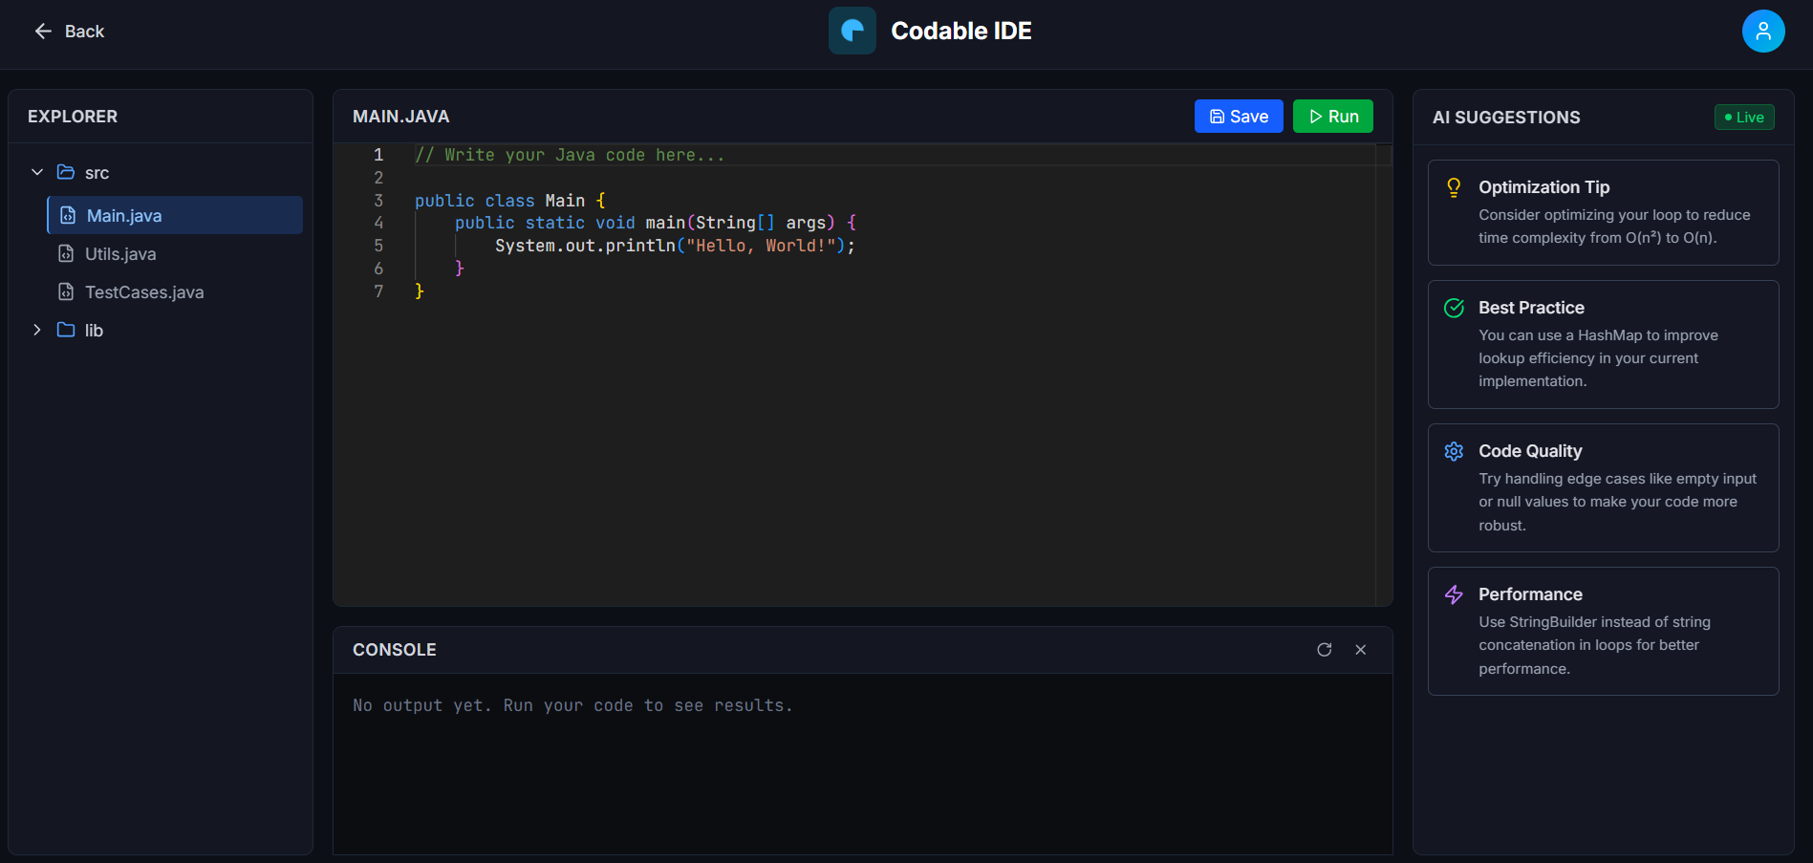
  - Purpose: Write, compile and run Java code in-browser.
  - Key components: Monaco editor, Run/Stop buttons, stdin input, stdout/stderr console, file tabs.
  - Primary actions: edit code, click Run → stream compile/runtime output, provide stdin.
User Profile & Analytics
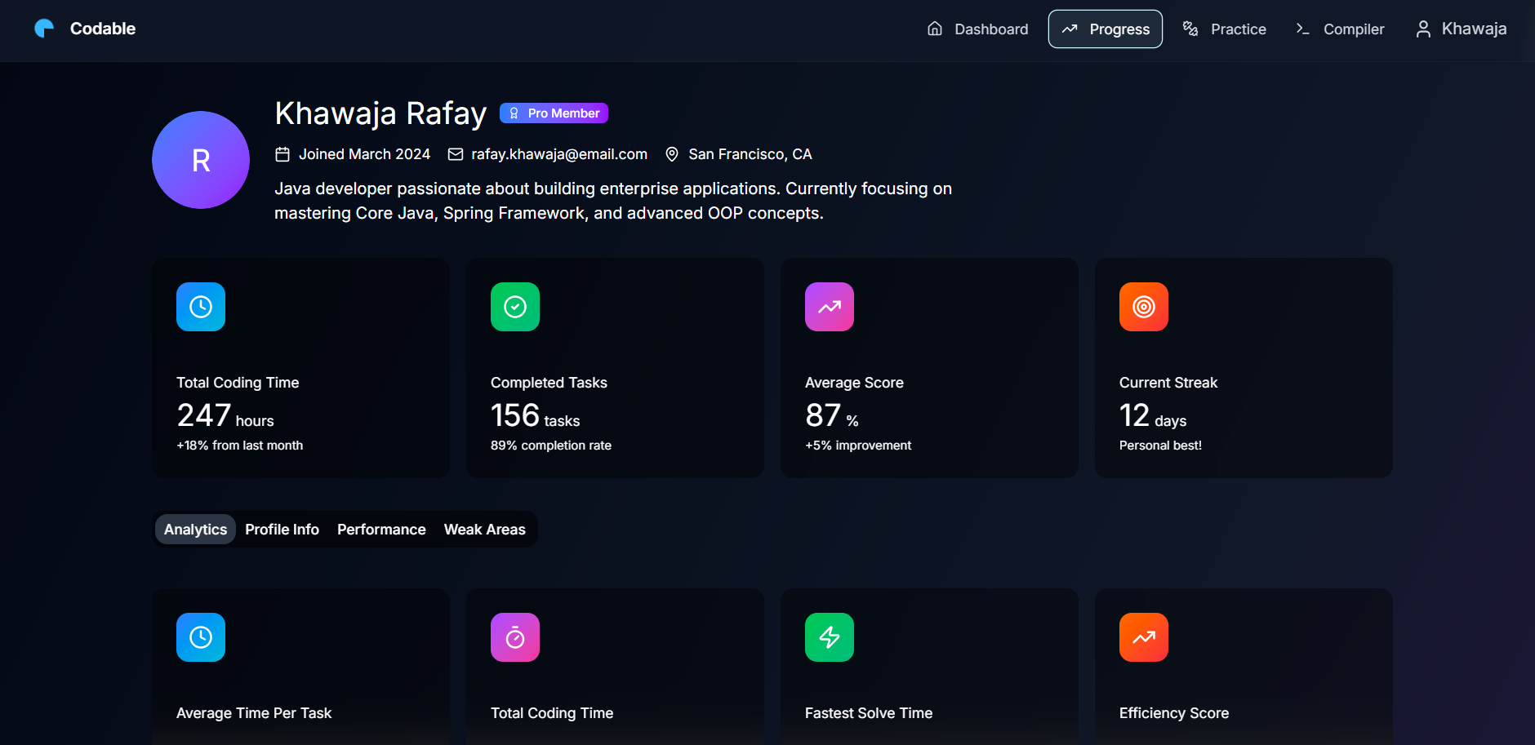
  - Purpose: Provide users a single place to view and update their personal information and identity details.
  - Key components: Avatar, name, membership badge, bio, location, social links, join date, and an Edit button.
  - Primary actions: View profile info, open edit form, update details, and save changes with validation.

Instructor Dashboard
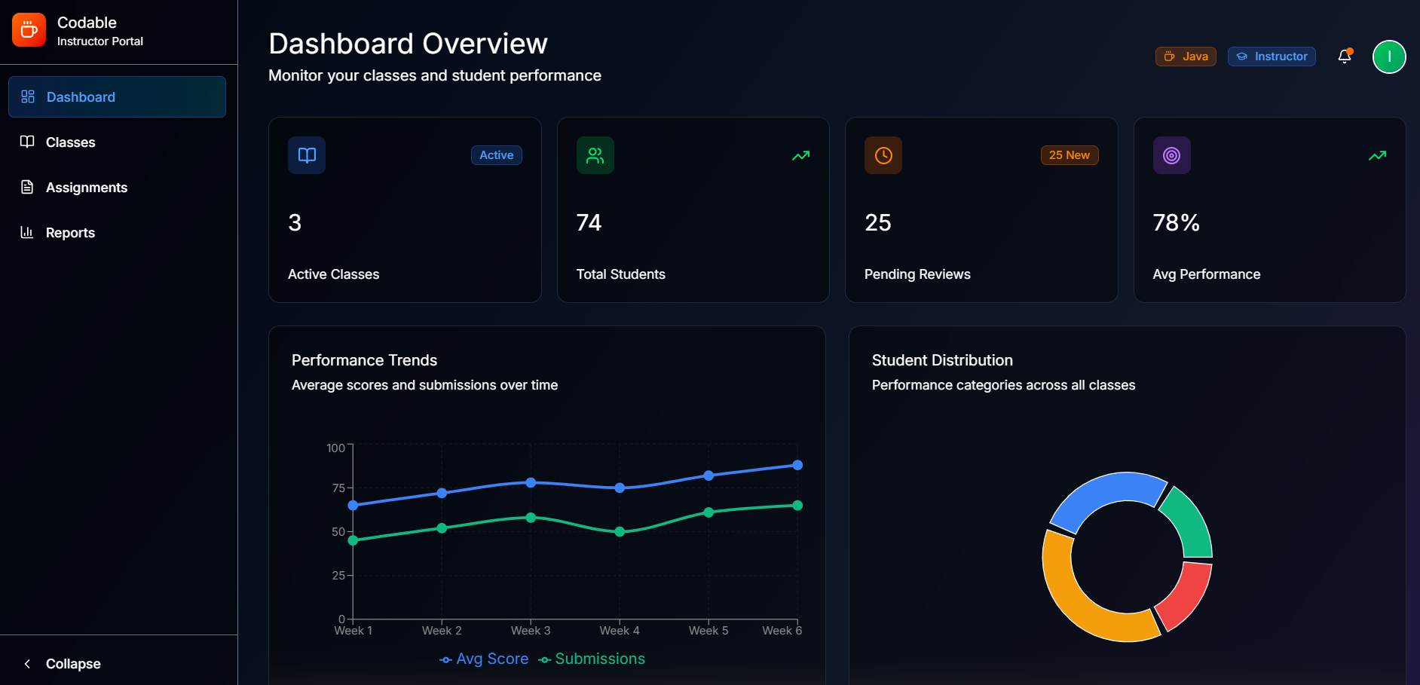
- Purpose: Manage users, view metrics, moderate content.
- Key components: user list, search, role controls, platform analytics charts.
- Primary actions: edit user profiles, promote/demote roles, review code runs.

Create and view Classes (for instructor)
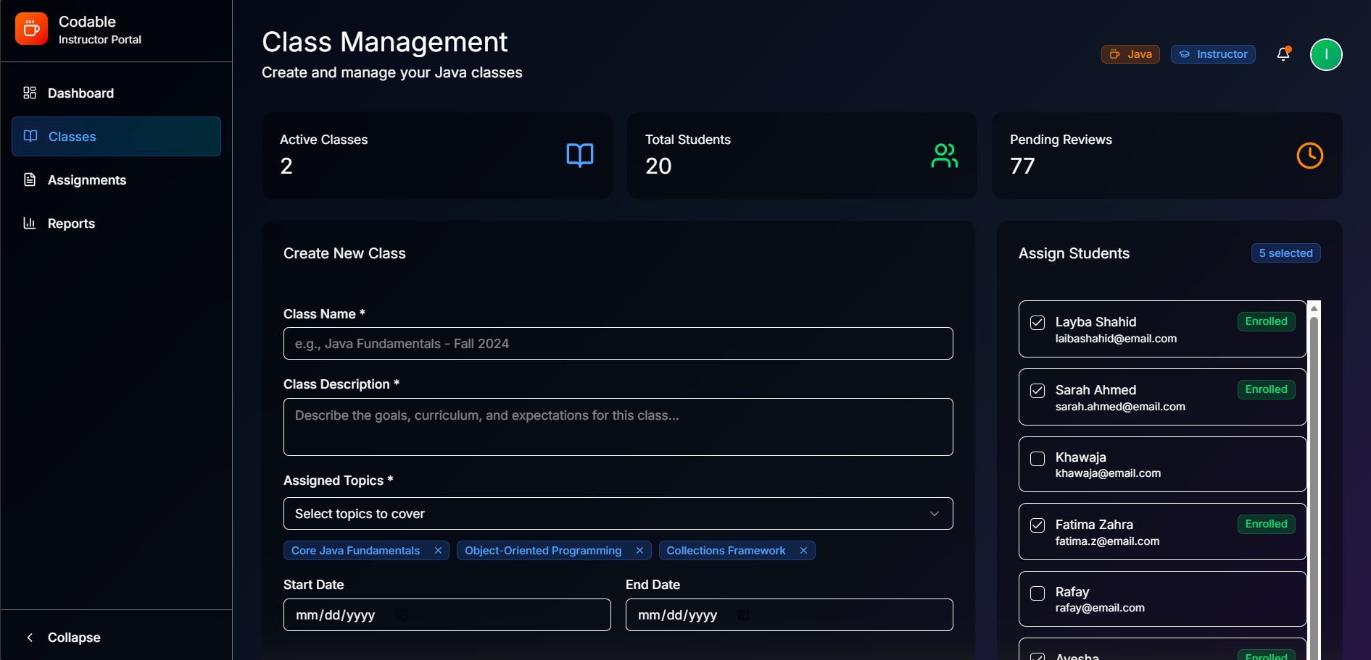

- Purpose: Create and publish a class/cohort with schedule, resources and visibility settings.
- Key components: Title & short description, rich-details editor, topics/tags selector, level & capacity inputs, schedule/date pickers, visibility & enrollment code, action bar (Preview, Save Draft, Publish)
- Primary actions: Fill required fields → Preview class card → Save draft or Create/Publish

Chapter 5: Testing and Evaluation

This section is to perform testing of the system and to ensure that the system working as intended. This is also to check that the system meets the requirements stated earlier. Besides that, system testing will help in finding the errors that may be hidden from the user

Unit Testing
Unit testing verifies the smallest testable components of the software (e.g., individual functions, methods, or classes) in isolation. The purpose is to ensure that each unit performs as expected, independent of the full system.

Test 1: validateEmail()
No. | Test case / Test script | Attribute & Value | Expected Result | Actual Result
1 | Call validateEmail() with valid email | "abc@gmail.com" | Validates as correct email (True) | True
2 | Call validateEmail() with invalid email | "abc.gmail.com" | Rejects input and returns False | False
3 | Call validateEmail() with empty string | "" | Rejects input and returns False | False

Test 2: User model : password hash & compare
No. | Test case / Test script | Attribute and Value | Expected Result | Actual Result
1 | Save user with plain password | password: "password123" | Stored password != "password123" (hashed) | False
2 | comparePassword() with correct password | comparePassword("password123") | Returns true | True
3 | comparePassword() with wrong password | comparePassword("wrongpass") | Returns false | False

Test 3: Auth controller (login/register)
No. | Test case / Test script | Attribute and Value | Expected Result | Actual Result
1 | Save user with plain password | password: "password123" | Stored password != "password123" (hashed) | False
2 | comparePassword() with correct password | comparePassword("password123") | Returns true | True
3 | comparePassword() with wrong password | comparePassword("wrongpass") | Returns false | False

Test 4: authMiddleware.userAuth
No. | Test case / Test script | Attribute and Value | Expected Result | Actual Result
1 | Call protected route without token header | no token header | 401 Unauthorized | False
2 | Call with invalid/expired token | token: "invalid" | 401 Unauthorized | False
3 | Call with valid token | token: valid JWT for userId X | next() called; req.userId === X | True

Test 5: StudentProfile controller (create/get/update/delete)
No. | Test case / Test script | Attribute and Value | Expected Result | Actual Result
1 | POST /api/student/profile when none exists | payload {fullName,...} with auth token | 201 Created, profile created | True
2 | POST /api/student/profile when profile exists | same user repeated | 400 Bad Request (profile exists) | False
3 | GET /api/student/profile with valid token | auth token | 200 OK, returns profile + populated email/joinDate | True
4 | PUT /api/student/profile partial update | payload {bio:"new"} | 200 OK, bio updated | True
5 | DELETE /api/student/profile | valid token | 200 OK, profile removed | True

Test 6: Code-runner (compile & run)
No. | Test case / Test script | Attribute and Value | Expected Result | Actual Result
1 | Send valid HelloWorld Java code via WS run | class Main { public static void main... System.out.println("Hello"); } | WS messages: compile-success then stdout with "Hello" then done | True
2 | Send code with compile error via WS | malformed Java code | WS message: compile-error contains compiler stderr | False
3 | Long-running infinite loop code | code with while(true) | ExecutionGuard kills process after timeout; receive killed-timeout | False

Functional Testing
Functional testing validates that the system modules work correctly as a whole, ensuring that the developed system meets its specifications and requirements. Unlike unit testing, which focuses on internal functions, functional testing evaluates user-facing features through the UI or APIs.

No. | Test Case | Attribute and value | Expected Result | Actual Result
1 | Login as Student | email: student@example.com, password: password123 | Redirect to Student dashboard; navbar shows student links | TBD — execute test
2 | Login as Mentor | email: mentor@example.com, password: mentorpass | Redirect to Mentor dashboard; mentor controls visible | TBD — execute test
3 | Signup new user (student) | name, email newuser@example.com, password | 201 Created; token returned; optional create StudentProfile step triggered | TBD — execute test
4 | Splash screen visibility | Fresh browser session open site | Splash displays once; after timeout or dismiss, app shows routes; on page reload same session splash not shown | TBD — execute test
5 | Access protected route without token | GET /api/student/profile (no token) | 401 Unauthorized or redirect to login | TBD — execute test
6 | Create Student Profile (first-time) | POST /api/student/profile with valid payload + auth token | 201 Created; profile stored; GET /api/student/profile returns populated profile + email and joinDate | TBD — execute test
7 | Edit Student Profile (UI) | Open Edit modal, change bio & location, Save | PUT /api/student/profile called; UI updates with new bio/location; server returns 200 and updated data | TBD — execute test
8 | Workspace run — successful program | Send HelloWorld Java via WS run | WS messages: compile-success → stdout "Hello" → done; console shows output | TBD — execute test
9 | Workspace run — compile error handling | Send malformed Java via WS run | WS message: compile-error with compiler stderr; UI shows compile error panel | TBD — execute test
10 | Workspace run — execution timeout | Send infinite-loop code via WS run | ExecutionGuard kills process after timeout; client receives done/killed-timeout; UI shows timeout message | TBD — execute test
11 | Mentor create class (UI) | Fill form: title, description, schedule, publish | POST /api/mentor/classes returns 201; redirect to class detail/management | TBD — execute test
12 | Membership upgrade | PUT /api/student/membership/upgrade { tier: "pro" } + auth | 200 OK, membershipTier updated to pro; UI shows Pro badge | TBD — execute test
13 | Logout & token invalidation | Click Logout (frontend) or remove token | Protected routes return 401; user sent to login | TBD — execute test

Integration Testing
Integration testing verifies that different modules of the system work together correctly. Unlike unit testing (which checks isolated functions) and functional testing (which checks features from a user’s perspective), integration testing focuses on the interfaces, linkages, and data flow between modules developed by different team members.

Test 1: Signup / Auth ↔ StudentProfile creation & retrieval

No. | Test case / Test script | Attribute and value | Expected result | Actual result
1 | Register new user → Login to get token | POST /auth/signup { name, email: newuser@example.com, password } → POST /auth/login { email, password } | Signup returns 201 (or success); login returns token and user info | TBD — execute test
2 | Create StudentProfile using token | POST /api/student/profile with header token: <JWT> and body { fullName, bio, location, socialLinks } | 201 Created; StudentProfile saved with userId referencing User._id | TBD — execute test
3 | GET profile and validate populated fields | GET /api/student/profile with header token: <JWT> | 200 OK; response contains profile fields and populated userId.email and userId.createdAt (joinDate) | TBD — execute test
4 | Prevent duplicate profile creation | POST /api/student/profile again with same token | 400 Bad Request (profile already exists) | TBD — execute test

Test 2: Profile lifecycle & middleware enforcement (Create → Update → Delete)
No. | Test case / Test script | Attribute and value | Expected result | Actual result
1 | Access protected endpoint without token | GET /api/student/profile (no token header) | 401 Unauthorized (authMiddleware.userAuth blocks access) | TBD — execute test
2 | Create profile, then partial update | POST /api/student/profile (auth token) then PUT /api/student/profile { bio: "New bio" } | POST returns 201; PUT returns 200 and profile.bio updated in DB | TBD — execute test
3 | Verify persistence after update | GET /api/student/profile (auth token) | 200 OK; bio value matches updated text and updatedAt changed | TBD — execute test
4 | Delete profile and validate removal | DELETE /api/student/profile (auth token) then GET /api/student/profile | DELETE returns 200; subsequent GET returns 404 (not found) | TBD — execute test

